PLTW_M_L_4CP

|  |
| --- |
| **Activity 1.5*The Deep Dive*** |

Introduction

How do professional design companies work through a design process? The video you are about to see chronicles the efforts of a world-renowned design firm, as they apply their process to the redesign of a common, everyday product.

One of the best-documented examples of the design process in action took place in Palo Alto, California, at an industrial design firm called IDEO. ABC News gave IDEO the challenge of redesigning the old and familiar shopping cart in just five days. *Nightline* chronicled the experience and aired the program on February 9, 1999.

This short documentary reinforces the idea that fantastic solutions can be produced under very difficult constraints when the designers have a commitment to the problem, a firm understanding of a design process, and a willingness to operate as a team.

In this activity you will watch the Deep Dive documentary and record information related to the design process used in the redesign of a shopping cart.

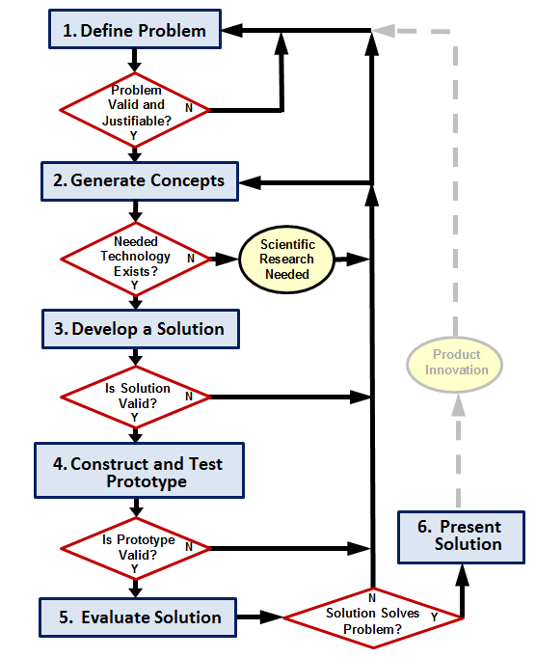

Equipment

* VCR or DVD player
* Television
* The Deep Dive DVD

Procedure

In this activity you will watch a group of professionals work to solve a design problem in just five days. Answer the following questions as you watch The Deep Dive.A class discussion will take place following the broadcast.

1. “From the buildings in which we live and work, to the cars we drive, or the knives and forks with which we eat, everything we use was designed to create some sort of marriage between \_\_\_\_\_\_\_**form**\_\_\_\_\_\_\_\_\_\_ and \_\_\_\_\_\_**functions**\_\_\_\_\_\_\_\_\_\_\_.”
2. The folks at IDEO state that they are not experts in any given area. But they do claim to be experts on the \_\_\_\_\_\_\_**design**\_\_\_\_\_\_\_\_\_\_\_\_\_, which they apply to the innovation of consumer products.
3. After the team of designers is brought together, introduced to the problem, and informed they have five days to “pull it off,” what phase of the design process do they immediately engage in? **research**
4. Give two examples of what the team members did during this phase.
   1. **Went into groups and got ideas.**
   2. **Researched the goods and bads about the carts.**
5. List five rules-of-thumb that IDEO employees follow when they share ideas during the brainstorming phase:
   1. **One conversation at a time.**
   2. **Stay focused on topic.**
   3. **Encourage wild ideas.**
   4. **Don’t worry about failing.**
   5. **Give ideas.**
6. Why should wild (and sometimes crazy) ideas be entertained during the brainstorming phase?

**Crazy ideas are good and you can work with them and build off of them.**

1. After the brainstorming phase was over, the team narrowed down the hundreds of ideas by \_\_\_\_**looking**\_\_\_\_\_\_\_\_\_ for those ideas that were not only “cool” but also \_\_\_\_**practical**\_\_\_\_\_\_\_\_\_\_\_\_\_ in a short period of time. Which phase of the design process includes brainstorming and narrowing ideas?
2. IDEO believes that the ideas and efforts of a \_\_\_**team**\_\_\_\_\_\_\_\_\_\_\_ will always be more successful than the planning of a lone genius.
3. Once the ideas were narrowed down and divided into categories, the group was split into four smaller teams. For which phase(s) of the design process was each of these groups responsible? **They all gave ideas and they used all of them to make the final product.**
4. The leaders at IDEO believe that \_\_\_\_\_\_**fun**\_\_\_\_\_\_\_\_\_\_ behavior and a \_\_\_\_**fun**\_\_\_\_\_\_\_\_\_\_ environment are two important reasons why their employees are able to think quickly and creatively to produce innovative results.
5. Sometimes, people come up with great solutions that work by trying their ideas first and asking for \_\_\_\_\_**forgiveness**\_\_\_\_\_\_\_\_\_\_\_\_ later.
6. Design is often a process of going too far and having to take a few steps back. What phase(s) of the design process would the critique of the four mock-ups come under? **Encourage crazy ideas.**
7. Upon critique of the four teams’ models, it was obvious that none of the teams had developed an optimum solution. However, the people at IDEO believe that it is important to \_\_\_**fail**\_\_\_\_\_\_\_\_\_\_ often in order to \_\_\_\_**succeed**\_\_\_\_\_\_\_\_\_ sooner.
8. What percentage of the entire week’s time did it take to fabricate the final prototype? **10%**
9. Instead of showering his design team with a tremendous amount of praise, what did the boss require his employees to do with their new design?

**Have them take it to a market and see how it works and see what other people think of it and see if anyone has anything to say about it.**

1. Of all the things that we are surrounded by every day, what has not been placed through the design process? **Nature.**

Extend Your Understanding (Optional)

Engineers need to know what problems they are addressing. They must have an idea about the degree to which the solution should be carried out, along with what the solution should do to solve the problem. The engineer must also work within constraints, such as time and budget. A design brief is a tool that is used to concisely identify the problem, solution expectations, and project constraints. The engineer will often return to the design brief throughout a design process to assess the progress and validity of his or her creative work.

Imagine that you are part of that design team. The project leader has given you the responsibility of creating a **design brief** that defines the problem, states the expectations that the solution must meet, and identifies the project criteria and constraints. Your design brief will serve as a guide to the team as they work through the design process.

From your observations of the video, record your information in the design brief on the following page or in your engineering notebook.



|  |
| --- |
| **Shopping Cart Redesign Design Brief** |

|  |  |
| --- | --- |
| **Client:**  *Who is the customer or client that is paying for the design service?* |  |
| **End User:**  *Who is going to use the new product?* |  |
| **Designer(s):**  *Who was responsible for the design of the revised grocery cart?* |  |
|  |
| **Problem Statement:**  *What was the problem that the design team was trying to solve? Write your answer as a complete sentence.* |  |
|  |
|  |
|  |
|  |
| **Design Statement:**  *To what degree was the solution to be realized? Was the design team’s intention to merely sketch an idea and be done? Was the intention to come up with an idea, build it, and stop there? Or, was it the design team’s intention to design, build, and test an idea? What expectation(s) did the design have to meet before it would be considered a successful solution to the problem? In other words, what did the solution have to do?* |  |
|  |
|  |
|  |
| \_\_\_\_\_\_\_\_\_\_\_\_\_\_\_\_\_\_\_\_\_\_\_\_\_\_\_\_\_\_\_\_\_\_\_\_\_\_\_\_\_\_\_\_\_\_\_ |
| **Criteria & Constraints:**  *What criteria did the solution have to meet? What limitations did the design team have to work with? Was there a time constraint to get the project finished?* |  |
|  |
|  |
|  |
|  |

Conclusion

1. What was the most impressive part of the team’s effort?
2. What advantages are there to having adesign team with members that have non-engineering backgrounds?
3. There was a point in the process where a self-appointed group of adults stepped up, stopped the ideas, and redirected the group to break up into teams. Why was this done?
4. At the end of the video, Dave Kelly states, “Look around. The only things that are not designed are the things we find in nature.” Can you think of anything that would contradict this statement?
5. Consider the various versions of a design process (below) that were introduced in the Design Process presentation that you viewed. How are the processes similar? How are they different?

|  |  |
| --- | --- |
|  |  |
| Design_Process_Logo  ITEA Standards for Technology Literacy | Design Process used in IED |

1. Do you think the tasks completed by the design team during the design challenge or the final solutions have changed if the team had followed a different version of a design process? Explain.